Java Class
A class is a basic building block of object oriented programming. It is set of objects that shares common characteristics/behavior and common properties/attributes. It is user-defined prototype or blueprint from which objects are created. A class represents real life entities. For example, Student is a class while a particular student named Ravi is an object.
Properties of Java Classes
- Class is not a real-world entity. It is just a template or blueprint or prototype from which objects are created.
- Class does not occupy memory.
- Class is a group of variables of different data types and a group of methods.
Defining a Class in Java
In general, class declaration includes the following in the order as it appears:

- Modifiers: A class can be public or has default access.
- class keyword: The class keyword is used to create a class.
- Class name: The name must begin with an initial letter (capitalized by convention).
- Superclass (if any): The name of the class's parent (superclass), if any, preceded by the keyword extends. A class can only extend (subclass) one parent.
- Interfaces (if any): A comma-separated list of interfaces implemented by the class, if any, preceded by the keyword implements. A class can implement more than one interface.
- Body: The class body surrounded by braces, { }.

Declaration of Class
Syntax:
access_modifier class <class_name>
{
data member;
method;
constructor;
nested class;
interface;
}



example:

// Java Program for class example

Public class Student {
// data member (also instance variable)
int id;
// data member (also instance variable)
String name;

public static void main(String args[])
{
// creating an object of
// Student
Student s1 = new Student();
System.out.println(s1.id);
System.out.println(s1.name);
}
}

Constructors
In Java, constructors are special methods used to initialize objects. A constructor is called automatically when an object of a class is created. It has the same name as the class and does not have a return type (not even void). At the time of calling constructor, memory for the object is allocated in the memory.
It is a special type of method which is used to initialize the object. Every time an object is created using the new keyword, at least one constructor is called.
It calls a default constructor if there is no constructor available in the class. In such case, Java compiler provides a default constructor by default.
It is called constructor because it constructs the values at the time of object creation. It is not necessary to write a constructor for a class. It is because Java compiler creates a default constructor if your class does not have any.
Rules for Creating Constructors
- Constructor name must be the same as its class name.
- A Constructor must have no explicit return type.
- A Java constructor cannot be abstract, static, final, and synchronized.
- We can use access modifiers while declaring a constructor. It controls the object creation. In other words, we can have private, protected, public or default constructor in Java.

Types:
- Default Constructor (no-arg constructor)
- Parameterized Constructor

Java Default Constructor(no-argument constructor)
Constructor with no parameter is known as Default constructor.
Syntax:
Class_name(){}
Example:
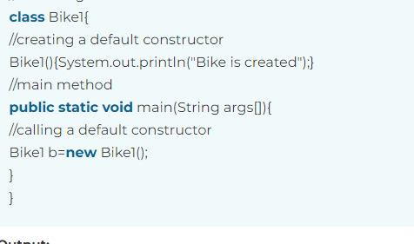

Note: If there is no constructor in a class, compiler automatically creates a default class.

Inheritance
Inheritance in Java enables a class to inherit properties and actions from another class, called a superclass or parent class. A class derived from a superclass is called a subclass or child group. Through inheritance, a subclass can access members of its superclass (fields and methods), enforce reuse rules, and encourage hierarchy.
The idea behind inheritance in Java is that we can create new classes that are built upon existing classes. When we inherit methods from an existing class, we can reuse methods and fields of the parent class. However, we can add new methods and fields in your current class also.
Why use inheritance in Java?
- For Method Overriding (so runtime polymorphism can be achieved).
- For Code Reusability.
Syntax:
class Subclass-name extends Superclass-name
{
//methods and fields
}
Types of Inheritance
- Single Inheritance
- Multilevel Inheritance
- Hierarchical Inheritance
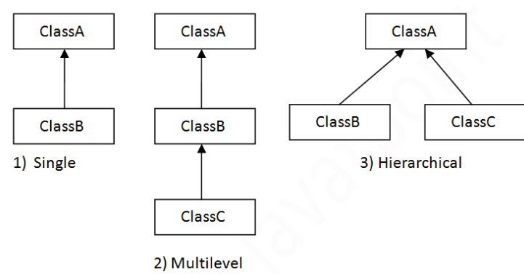

Multiple Inheritance is not supported in Java through classes.

Example:
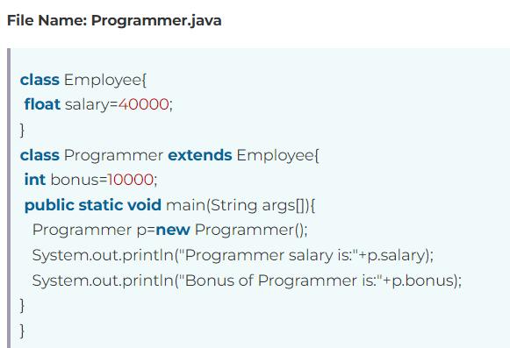

Benefits of Inheritance
Inheritance offers several advantages, including:
- Code Reusability: Inherited members from a superclass can be reused in subclasses, reducing redundant code and promoting a modular approach to software development.
- Hierarchical Organization: Inheritance facilitates the creation of well-structured class hierarchies, improving code readability and maintainability.
- Polymorphism: Subclasses can override superclass methods, allowing for polymorphic behavior, where methods can behave differently based on the object type at runtime.
- Easier Maintenance: Changes made to a superclass automatically propagate to its subclasses, ensuring consistency and simplifying maintenance efforts.
Write Example of each…
Interface:
An interface in Java is a blueprint of a class. It has static constants and abstract methods.
The interface in Java is a mechanism to achieve abstraction. There can be only abstract methods in the Java interface, not method body. It is used to achieve abstraction and multiple inheritance in Java.
Why use Java interface?
There are mainly three reasons to use interface. They are given below.
- It is used to achieve abstraction.
- By interface, we can support the functionality of multiple inheritance.
- It can be used to achieve loose coupling

Syntax:
interface <interface_name>{
// declare constant fields
// declare methods that abstract
// by default.
}
Example:

interface Animal {
void eat();
void sleep();
}

